# FT NavVision© settings

## Introduction

For the proper functioning of the HMS it is necessary that we make some settings in NavVision and have certain files in the NavVision/config/network folder. These settings and files are essential, so we will discuss them here.

## CAP437ReportStructure.html

This file represents the structure of the report that will be sent to the customers once you have pressed the generate report button. This file can be changed over time. It is necessary that you check if this file is available in NavVision/config/network. At this moment the date of the file needs to be 26-4-2013 and it will be 8.51kB. Check this. If it changes, you will be informed.

## SMTPConfig.uc.ini

This file is for the settings of your SMTP server. You DO NOT need to adjust this file to have it sending the reports as an email over your own SMTP server. It will look like the following:

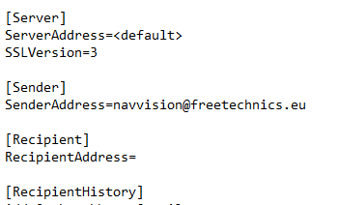

Figure 3‑1: SMTPConfig.uc.ini

This file will be generated the first time that you generate a report.

You will have to fill in your own information and add a few lines for your username and password. The next figure is an example. You need to adjust it to your own settings.

|  |  |
| --- | --- |
| Field | Explanation |
| ServerAddress | Address of the ships SMTP server or default |
| SSLVersion | 1-no authentication, 2=STARTTLS, 3=SSL/TLS |
| SenderAddress | The name you want as sender |

Table 3‑1: SMTPconfig

## Vessel.ini

In vessel.ini some specific information is kept with information about the vessel. For the HMS it is in some parts important if you want to change things as the name of the vessel or the picture of the vessel in the compass.

Under the paragraph [Vessel] you can give the ships name (see Figure 3‑2). This is the name that will be used as sender in the E-mail.



Figure 3‑2: Vessel.ini Name

The image that is used in the compass will be made as a proprietary image for the client. This image can be an image of the specific ship or platform with the helideck on it.

**

*: These images need to be made by Imtech while there need to be set some placeholders. DO NOT attempt to make them yourself.*

These images can have some child-objects to give the image some interaction like perimeter-lights or obstruction warning etc.

The routing to these images and child-objects can be set in the Vessel.ini. First you set the [HeliView] which is the place where you set the basic image for that HMS (see Figure 3‑3). At “FileName” you give the link to the image. This is a conditional link.

Under the “ChildObject” section, you refer to the other dependencies.

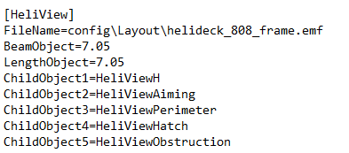

Figure 3‑3: Vessel.ini image and child-objects

Each Child-Object has its own image and its own paragraph. So for ChildObject1 there is a new paragraph with the name [HeliViewH] which in this case is the illuminated letter H on the helideck (see Figure 3‑4). Here you route the FileName to the appropriate image which in this case is “helideck_808_h.emf”.



Figure 3‑4: Vessel.ini ChildObject

Furthermore you can set some I/O (or Fields within NavVision) that gives the interaction with sliders or buttons on the mimic (see Figure 3‑5).

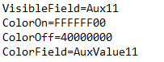

Figure 3‑5: Vessel.ini I/O fields

Here you see that a button/slider (Aux11) is used to switch the lighting on the image on or off. Also a color range is set and a valuefield to show that color.

As you finished this you will have a proprietary image in your mimic for that ship (see Figure 3‑6).

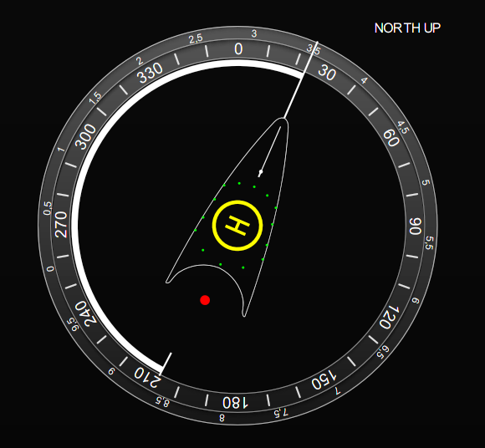

Figure 3‑6: Proprietary HMS mimic

**

: *Also check the NavVision/config/network folder that the following two (2) files are present. These are needed for the Email connection:*

libeay32.dll

libssl32.dll